**Tracing Stage**

In this stage, I went through the programs to trace the problem for the bugs. We used this method to find the origin of the bug. There are two reported bugs in the program. First one is the service charges are not appearing correctly during the checkout and so I went through addServiceCharges method of all the codes and figured out that one of the arguments passed in the method in one class was spelled incorrectly. Second bug is that the room can be added service charges even after the guest has checked out and so it is obvious from the nature of the bug that the state of the room is not changing and the new bookings are not removed from it. So, I went through all the entities of the program to trace the origin of the bug. The screenshots of the origin of the bugs are given below.

**Screenshot of Origin of Bug 1:**

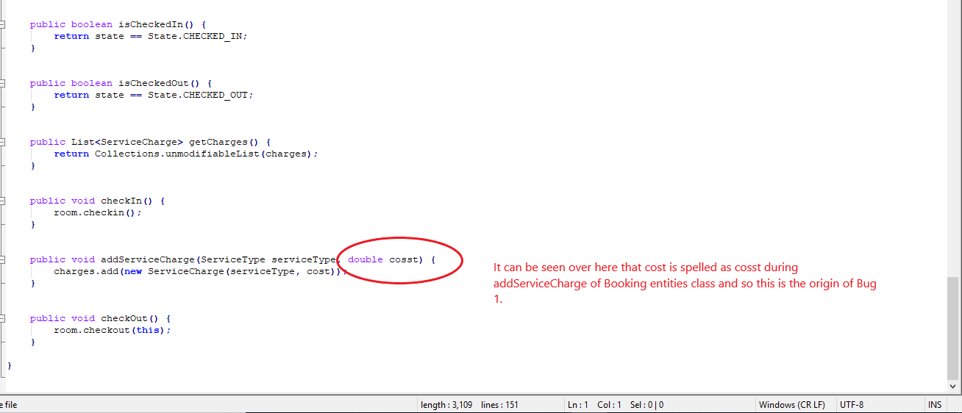

Thus, it can be seen in above screenshot that the origin of the bug 1 is due to the misspelled cost i.e. argument for addServiceCharge method.

**Screenshot of Origin of Bug 2:**

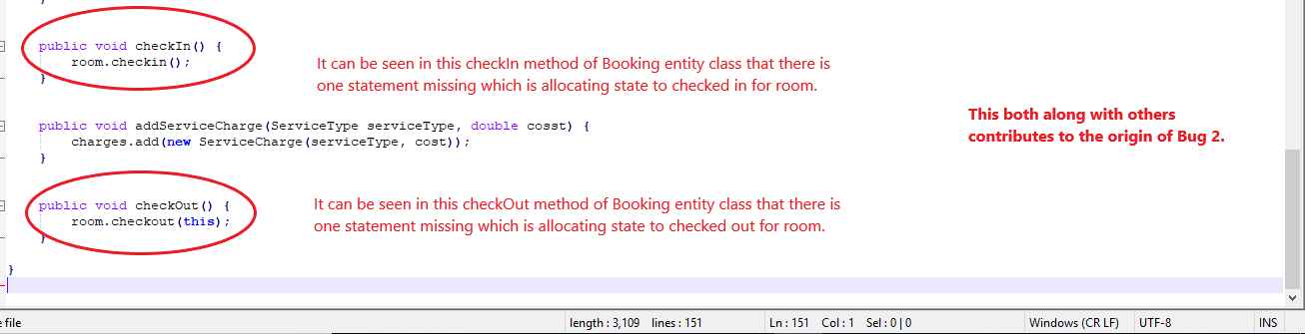

It can be seen above screenshot that the origin of Bug 2 is due to some of the missing statements of state change in the Booking entities class and there are some other reasons as well for which the screenshots are given below of the origin.

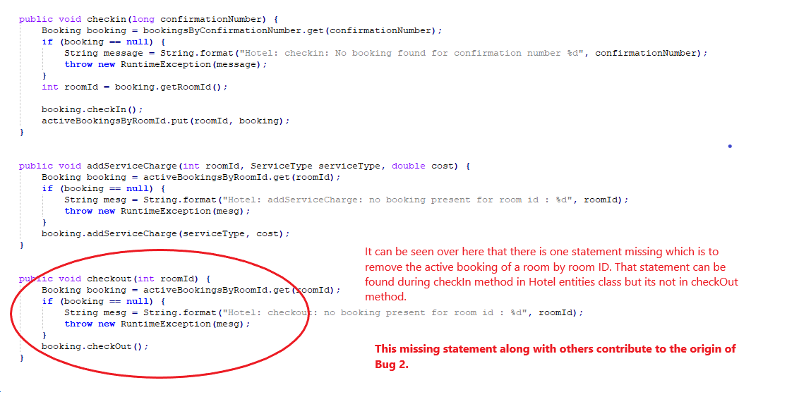

One of the other reason for Bug 2 is that from the hotel entities class the active booking is not removed. The screenshot of other origin of Bug 2 can be found below.

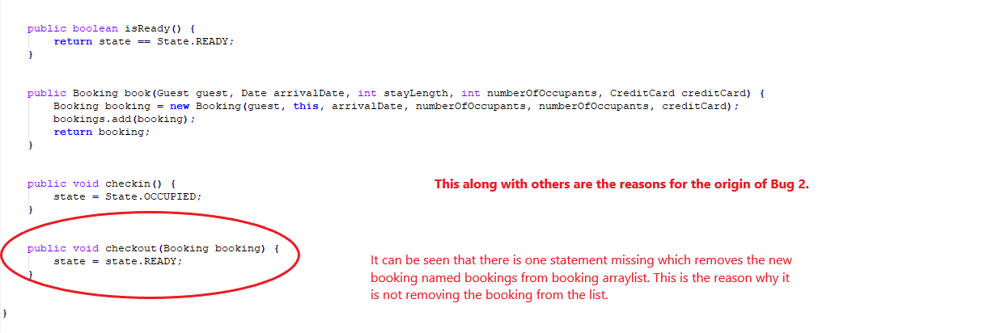

Last reason for Bug 2 is that the statement is missing in Room entities class. The booking is not removed in checkout method and this is also another origin for Bug 2.

Thus, in this tracing stage, I went through all the code to trace back the origin of the bugs and the screenshots of the origin of the bug can be found above.